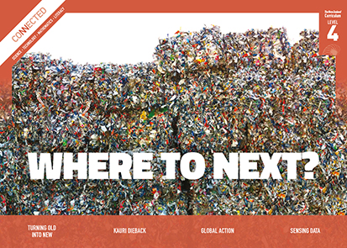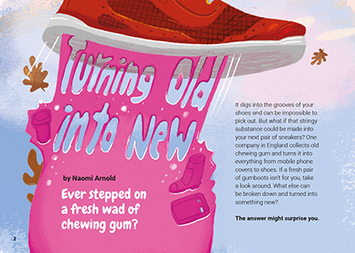
Connected
Level 4
2017

Turning Old into New
by Naomi Arnold

Overview
This article is about recycling. It describes the reasons for recycling – both to avoid waste and to save some of our limited natural resources. It also looks at some methods of recycling and uses of recycled products.
A Google Slides version of this article is available at www.connected.tki.org.nz.

Curriculum contexts

SCIENCE: Nature of Science: Participating and contributing  Level 4 – Students will:  - use their growing science knowledge when considering issues of concern to them  - explore various aspects of an issue and make decisions about possible actions. | Key Nature of Science ideas  When we engage scientifically with an issue, we:  - Look for a range of scientific information that relates to the issue  - Check that information we use is from a trustworthy source  - Consider the reliability and validity of the evidence  - Decide if and how to respond to the issue, justifying our decisions based on evidence and/or reliable scientific information  - Monitor the effects of any actions we take.
SCIENCE: Material World: Properties and changes of matter  Level 4 – Students will group materials in different ways, based on the observations and measurements of the characteristic chemical and physical properties of a range of different materials. | Key science ideas  - All products contain substances that originally came from a natural source.  - Some resources are renewable; others are not.  - Recycled materials often have properties that are different from those of the original material.  - Recycling can involve changing substances physically and/or chemically.  - The supplies of some raw materials will get used up unless we find new ways to retrieve and/or conserve them.  - We can recycle some kinds of rubbish more easily than others so that we can sustainably use the materials present on Earth.
ENGLISH: Reading  Level 4 – Ideas: Students will show an increasing understanding of ideas within, across, and beyond texts. | Indicators  - Makes meaning of increasingly complex texts by identifying and understanding main and subsidiary ideas and the links between them.  - Makes connections by thinking about underlying ideas within and between texts from a range of contexts.  - Recognises that there may be more than one reading available within a text.  - Makes and supports inferences from texts with increasing independence.
TECHNOLOGY: Technological Knowledge: Technological products  Level 4 – Understand that materials can be formed, manipulated, and/or transformed to enhance the fitness for purpose of a technological product. | Key technology ideas  - Societal and environmental issues can influence what technological products are made.  - Sometimes the way we use and dispose of materials makes it very hard to use them again in some other form.  - We need to use the materials present on Earth sustainably.  - In their uses of materials, people must take all the properties of the materials into account.  - New recycling technologies expand the products that can be made from items that would otherwise be thrown in a landfill.

The New Zealand Curriculum

Science capability: engage with science

Capability overview
This capability requires students to use the other capabilities to engage with science in real-life contexts. It requires students to take an interest in science issues, participate in discussions about science, and at times, take action.  The dimensions of this capability can be demonstrated when students engage in discussions about science issues, including those in the media. If these discussions build on the ideas of others, emphasise logical connections, and draw reasonable conclusions, and if the speakers make the evidence behind their claims explicit, then students have the opportunity to practise playing the “game of science” (Resnick, Michaels, & O’Connor, 2010). | This allows them to deepen their understanding of what science is.  Students also need opportunities to be actively engaged in exploring real-life science issues that are relevant to them and their communities. This could involve building new knowledge with others and taking action to address local or global concerns.

More about the capability

The capability in action
Real-life science issues:  - may involve a mix of scientific issues and forms of social-science inquiry, including values and ethics  - provide opportunities to build awareness of which questions can be investigated and which questions science does not answer  - provide opportunities to see science as tentative, that is, developing over time as evidence is gathered or reinterpreted  - provide experiences of uncertainty where there is no clear explanation or solution  - allow students to gather and interpret data about a local situation or to critique a range of evidence and claims  - may generate a range of student views, responses, and possible actions.  Students  Students should have opportunities to:  - take an interest in a range of scientific issues  - participate in discussions about scientific issues  - use their developing capabilities of gathering and interpreting data, using and critiquing evidence, and interpreting representations to create a viewpoint, response, or action on scientific issues.  Teachers  Teachers can:  - establish a science classroom culture by:  - taking a personal interest in scientific issues, modelling questions, explicitly critiquing evidence, and seeking further evidence | - maximising everyday opportunities to introduce learning conversations that engage students with science and scientific issues  - helping their students to notice and investigate science in their everyday surroundings, such as ice on a puddle, the health of a local stream or river, or what happens as materials are mixed or heated  - listening to and discussing socio-scientific items in the news  - exploring locally relevant and contentious scientific issues, such as irrigation, intensive farming, or the effects of climate change  - support students to identify scientific aspects of an issue  - provide a range of resources and investigation opportunities pertaining to scientific issues that require students to use a range of science capabilities  - encourage students to seek and critically evaluate a range of scientific evidence, opinions, and actions from a variety of sources about an issue  - manage with sensitivity situations where students and their whānau may hold differing and strongly held opinions about a science-related issue, such as irrigation  - support students to identify and take appropriate actions in response to science-related issues.  It is important that students are empowered to be hopeful and see opportunities for positive action and change when considering local and global issues.

More activities to develop the capability

Meeting the literacy challenges

The main literacy demands of this text require students to retrieve and integrate information to understand the impact that everyday materials have on the environment and the processes involved in recycling them. This text includes many complex sentences to explain these processes, often using cause-and-effect structures.  Students need to integrate technical information in the sidebars with the information in the body text in order to engage with the science ideas.  The text contains some illustrations and diagrams and an illustrated flow chart showing the process of recycling plastic bottles and turning them into clothing. | Students will need to use context and word knowledge to solve the vocabulary challenges, including topic-specific scientific terminology. Knowledge of prefixes and root words will support solving many of these words.  The following instructional strategies will support students to understand, respond to, and think critically about the information and ideas in the text.  You may wish to use shared or guided reading, or a mixture of both, depending on your students’ reading expertise and background knowledge.  After reading the text, support students to explore the activities outlined in the following pages.

INSTRUCTIONAL STRATEGIES

Finding the main ideas  PROMPT the students to read and DISCUSS the title and page 2.  Look at the title. How does it help you predict what this article will be about?  Why do you think the author is asking so many questions? What effect did these questions have on you as a reader? Is this a technique you might find useful when writing about science ideas?  As a class, LIST other things that can be turned into something new.  PROMPT the students to make connections to their prior knowledge about recycling.  What do you know about recycling? What are some key words you might need to know in order to talk to someone about recycling?  Skim through the article, looking at the headings and diagrams and running your eyes over the text. What are some other words that are related to this topic?  Have the students read the first paragraph on page 3 and think, pair, and share their responses to the questions.  PROMPT the students to notice the use of the en dash in the second paragraph on page 3.  That long dash is called an en dash. The en dash is a handy little punctuation mark that can bring a special emphasis to a sentence. This author has used the en dash for two different reasons. Can you see what they are? (To add an explanation and to add a note of suspense)  After reading page 4, have the students create a graphic organiser (see example below) to show the difference between renewable and non-renewable resources, with examples of each. | Natural resources  Renewable Non-renewable  Definition  Examples  PROMPT the students to notice the unintended consequences of recycling plastic drink bottles, which can then lead to the problem of poisoning underwater wildlife when microfibres enter the ocean via the sewerage system.  DISCUSS the author’s message.  What does the author want us to think about rubbish and recycling? What does she want us to do about it? How could you condense this into one sentence?  Do you agree with the author? Why? Why not?  Do you think other people would have different opinions?  Following the reading, REVIEW the students’ suggestions about what else could be turned into something new.  At the start, the author suggested that “the answer might surprise you”. What was her question? What was the answer? Were you surprised?  Now that you have read this article, have you recalled any other things that can be recycled?  Do you have new ideas of your own?

Meeting the literacy challenges

Dealing with scientific vocabulary  LIST the topic words and phrases the students have noticed. Then DISCUSS the strategies students might use to work out their meanings and RECORD them. These strategies may include:  knowing the word from another context  finding the definition in the text (for example, “process called manufacturing”)  finding a clue in the text  predicting the meaning from reading the text  using your knowledge of prefixes (for example, “re-cycle”, “re-newable”, “non-re-newable”, “re-set”, “bio-degradable”, “bio-capacity”)  looking at the structure of a compound word (for example, “glass/crete”, “glass/phalt”, “micro/fibres”, “over/shoot”)  noticing word families (for example, “natural resource”, “non-renewable resource”; “materials”; “breakdown process”, “processed”; “ecologist”, “ecological”)  checking the glossary  finding the meaning from a picture or diagram  using a reference tool, such as a dictionary, thesaurus, or the Internet.  Working in pairs or groups, have the students use a chart (see example below) to write what they think the technological terms mean when they first encounter them. They should then revise their definitions when they finish their reading. | Topic vocabulary: Recycling  Topic vocabulary What we think this means What we now know it means  materials  Using diagrams and visual features for deeper understanding  PROMPT the students to look closely at the pictures, diagrams, and other visual information.  How does visual information convey ideas?  What do you notice about the headings for different kinds of materials?  How do the illustrations and other design features in this article add to its appeal?  Look at the process diagram on page 7. What are some other ways this information could have been conveyed? Why do you think the designer chose this way?  Extending the learning  Challenge the students to create a process diagram that explains how plastic is made, using the text on pages 4 and 5. Alternatively, they could take the instruction for making recycled plastic into fabric on page 7 and rewrite it like a recipe using imperative verbs (commands).

Reading standard: by the end of year 8
The Literacy Learning Progressions
Effective Literacy Practice: years 5–8

Meeting the literacy challenges

TEACHER SUPPORT
Students take an interest in a scientific issue.

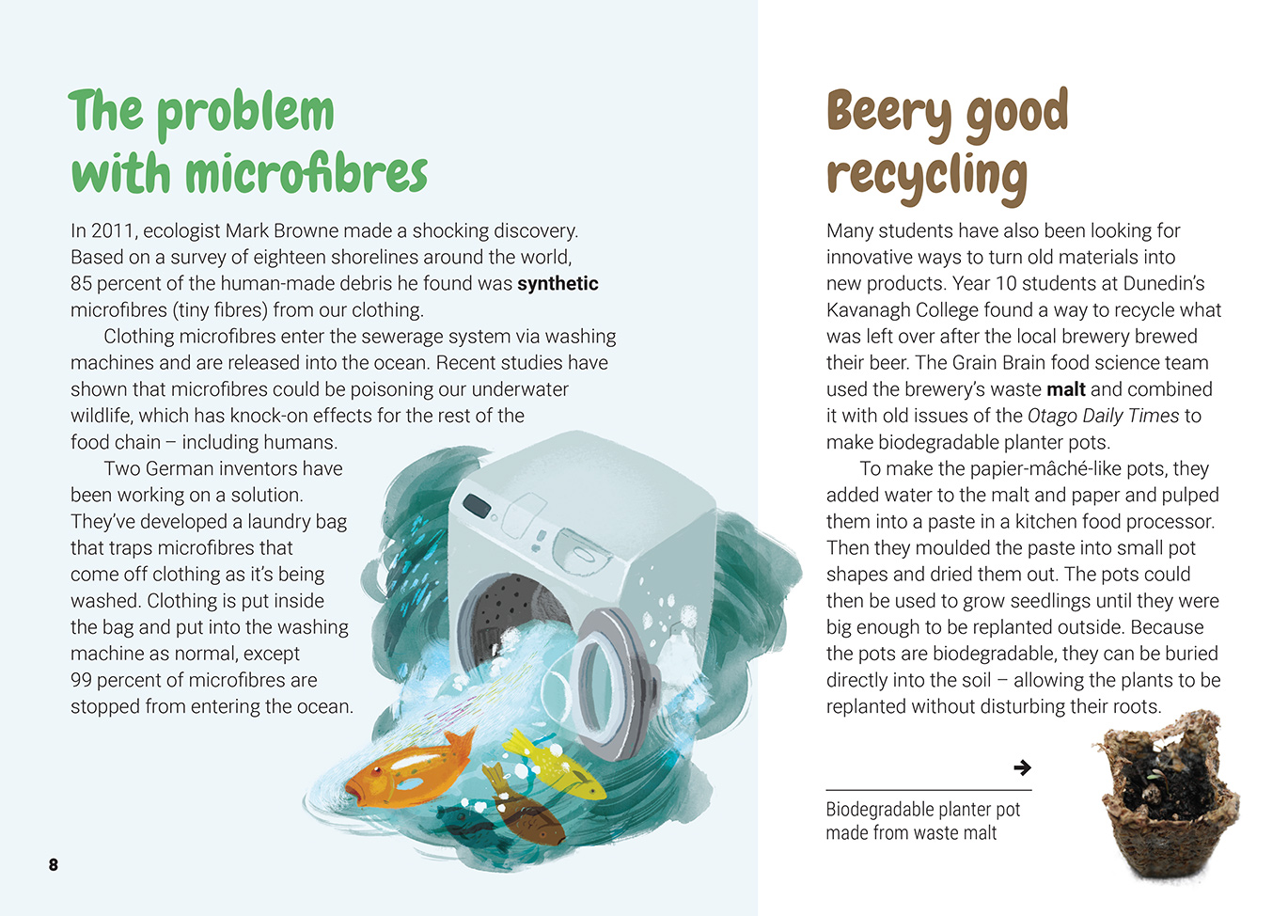
Societal and environmental issues can influence what technological products are made.
Scientists explore various aspects of an issue in order to make decisions about possible actions.
Recycled materials often have properties that are different from those of the original material.

The above page: Text and images copyright © Crown except: stoat (bottom left) by Nick Goodrum https://goo.gl/5k4VpX, which is used under a Creative Commons licence (CC BY 2.0), A24 trap (bottom middle) which is copyright © Goodnature, and beech forest (bottom right) from https://goo.gl/1kZqA3, which is in the public domain.

Learning activities – Exploring the science
The following activities and suggestions are designed as a guide for supporting students to explore and develop understandings about the science capability “engage with science”. Some activities focus directly on the science capability. Other activities extend student content knowledge across the learning areas. Adapt these activities to support your students’ learning needs.

Activity 1 – The problem with plastic
Have the students learn more about plastic identification codes, using the activity in Building Science Concepts Book 61, Recycling: New Uses for Rubbish (Section Three, Activity 2). Follow this with the activity on determining the properties of plastic and glass, described in Building Science Concepts Book 60, Rubbish: How Do We Deal with It? (Section Two, Activity 2).
Have the students investigate the long-term effects of plastic waste on our natural environment and the ways people are trying to address them. Examples include sea creatures getting tangled in plastic or eating microfibres; the Great Pacific Garbage Dump, the enormous pile of plastic and waste that has formed in the Pacific Ocean. See the Resource Links for sources. Encourage the students to use what they learn to develop a campaign to reduce the use of plastic at school and in the local community.

Extending the learning
Using what they have learned, the students could discuss the ethics of sending our plastic waste overseas for recycling, often to third-world countries. They may be interested in investigating other examples of waste products being shipped around the world for disposal, for example:
the computers and mobile phones that are sent to China
the ship graveyards in Pakistan and Bangladesh.

Activity 2 – Waste not, want not
Have the students sort the contents of a recycling bin into different types of product (bottles, cans, containers, etc).
Have each student choose one type of product to research. They should investigate:
what it is made from
where its components have come from
how it is manufactured
the energy required to manufacture it
how quickly and thoroughly it decays
how it is recycled.
Based on their learning, have the students make recommendations about how their product could be used in more sustainable ways and whether people should consider using alternatives.

Learning activities – Exploring the technology

Activity 1 – Taking up the challenge  Select activities from Building Science Concepts Books 60, Rubbish: How Do We Deal with It? and Book 61, Recycling: New Uses for Rubbish to help the students better understand the concepts of rubbish and recycling.  Ask students to work in groups to consider the author’s challenge to “think more deeply about what you throw away and how it could be used again”. Have each group share their ideas with the class.  Set up a recycling challenge. The students should use waste material to create something new.  Activity 2 – Innovating our way out of trouble?  Have the students explore the Science Learning Hub resources on the “biospife” – a compostable knife-come-spoon that was developed by ZESPRI in collaboration with other experts. Students can also learn about the recycled potato starch food packaging made by Potatopak. Support students to use these resources to develop their understandings about innovation, bioplastics, and biodegradability. They can then conduct the experiment for testing the degradability of three types of disposal plates. | Have the students read the Curious Minds article “Can Recycling Reduce Homelessness?”.  How is this an example of innovation?  What two problems are the students solving?  Have the students go online to find out about other innovative ways people have found to use waste products to address problems.  Guide the students to discuss the irony that the development of “innovative” new technologies has contributed a great deal to the waste in our world – yet we need innovative technologies to deal with this problem. Many everyday items, such as clothing, are often created quickly and cheaply and are not designed to last. We live in what is now called a “throwaway culture”.  Have these items enhanced our lives? Do they make us happy? Do the disadvantages outweigh the benefits?  Can new technological outcomes solve the problems brought about by older technologies?

Link to mathematics and statistics

Activity – Figure It Out
Two books in the Figure It Out series offer activities that link to the theme of this article: Sustainability (levels 2+–3+) and Using Resources (levels 3+–4+).

Learning activities – Exploring the science, technology, mathematics and statistics

RESOURCE LINKS

Building Science Concepts  Book 60, Rubbish: How Do We Deal with It?  Book 61, Recycling: New Uses for Rubbish  Connected  “A New life for Old Machines”, Connected 3, 2007  Science Learning Hub  Plastics and recycling: www.sciencelearn.org.nz/resources/2516-plastics-and-recycling  Flight Plastics recycling technology: www.sciencelearn.org.nz/resources/2517-flight-plastic-recycling-technology  Flight Plastics recycling plant in action: www.sciencelearn.org.nz/videos/1751-flight-plastics-recycling-plant-in-action  Composite materials: www.sciencelearn.org.nz/resources/1466-composite-materials  Waste management: www.sciencelearn.org.nz/resources/1458-waste-management  Bioplastics: www.sciencelearn.org.nz/resources/1474-bioplastics  Potatopak – Introduction: www.sciencelearn.org.nz/resources/1074-potato-plates-introduction  The ZESPRI biospife: www.sciencelearn.org.nz/resources/1472-the-zespri-biospife  Designing a new product from potato starch – unit plan: www.sciencelearn.org.nz/resources/1114-designing-a-new-product-from-potato-starch-unit-plan  Measuring biodegradability: www.sciencelearn.org.nz/resources/1543-measuring-biodegradability  Biodegradability, composability, and bioplastics: www.sciencelearn.org.nz/resources/1473-biodegradability-compostability-and-bioplastics  Figure It Out (Mathematics)  Sustainability, levels 2+-3+: https://nzmaths.co.nz/figure-it-out-carousel-interface#c=13;p=0  Using Resources, levels 3+-4+: https://nzmaths.co.nz/figure-it-out-carousel-interface#c=38;p=0  The Guardian  “A Million Bottles a Minute: World’s plastic binge ‘as dangerous as climate change’”: www.theguardian.com/environment/2017/jun/28/a-million-a-minute-worlds-plastic-bottle-binge-as-dangerous-as-climate-change | “38 Million Pieces of Plastic Waste Found on Uninhabited South Pacific Island”: www.theguardian.com/environment/2017/may/15/38-million-pieces-of-plastic-waste-found-on-uninhabited-south-pacific-island  “Plastic Fibres Found in Tap Water around the World, Study Reveals”: www.theguardian.com/environment/2017/sep/06/plastic-fibres-found-tap-water-around-world-study-reveals  Other sources  Curious Minds – “Can Recycling Reduce Homelessness?”: www.curiousminds.nz/stories/can-recycling-help-homelessness/  LEARNZ (virtual field trip): Love your rubbish – waste, or valuable resource?: http://rata.learnz.org.nz/summary.php?vft=katevalley173  Recycle: www.recycle.co.nz/helpnz.php  Fonterra Milk for Schools – Recycling: www.fonterramilkforschools.com/environmental/  Technology Online Biodegradable planter pots (Kavanagh College): http://technology.tki.org.nz/Resources/Student-showcases/Resistant-Materials-other/Biodegradable-planter-pots  Otago Daily Times – Young scientists present their projects: www.odt.co.nz/news/dunedin/young-scientists-present-their-projects  Emersons’ & Kavanagh College’s Grain Brains: www.nzifst.org.nz/myfiles/10PDCKavanaghGrain-Brains.pdf  Auckland Council – What Happens to My Recycling?: www.makethemostofwaste.co.nz/recycling/what-happens-to-my-recycling/  Christchurch City Council – Recycling: www.youtube.com/watch?v=KZ4nUT16lH0  Suffolk – What Happens to My Recycling?: www.greensuffolk.org/recycling/where-it-goes/what-happens-to-my-recycling/  ScienceDaily – Warning of shortage of essential minerals for laptops, cell phones, wiring: www.sciencedaily.com/releases/2017/03/170320110042.htm  Science Alert – Scientists just turned plastic bottles and bags into liquid fuel: www.sciencealert.com/scientists-just-turned-plastic-bottles-and-bags-into-liquid-fuel  Scientific American – Sculpted Science: Turn Milk into Plastic!: www.scientificamerican.com/article/bring-science-home-milk-plastic/  Climate Kids (NASA) – Recycle This!: https://climatekids.nasa.gov/recycle-this/  Plastic Adrift – Showing where plastic ends up: http://plasticadrift.org/?lat=-30&lng=157&center=-5&startmon=jan&direction=fwd

